We Do
Engross Foundation works across multiple sectors to promote inclusive, equitable, and sustainable development through research-driven and evidence-based interventions. Our integrated approach focuses on strengthening communities, improving livelihoods, and supporting informed decision-making for long-term impact.

Research, Survey & Impact Assessment
We conduct rigorous research, baseline and endline surveys, and impact assessments to understand community needs and evaluate programme effectiveness. Our evidence-based insights support better planning, policy formulation, and implementation.
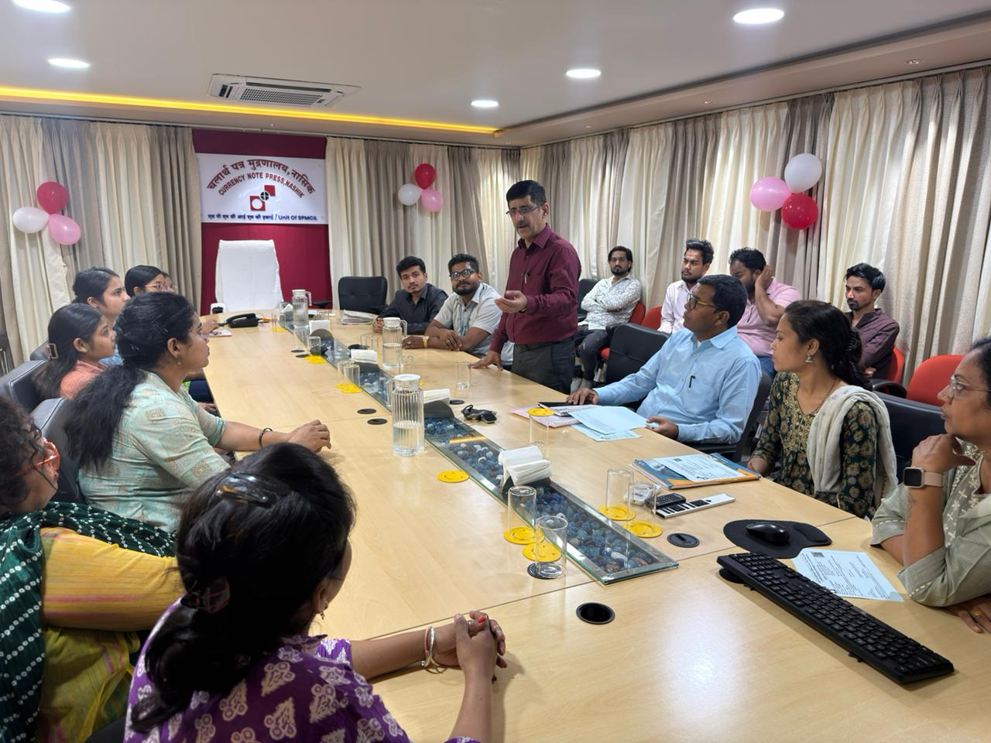

Livelihood & Economic Development
We promote sustainable livelihood opportunities by supporting skill-based employment, entrepreneurship, and micro-enterprises. Our initiatives aim to enhance income generation and economic resilience among vulnerable communities.

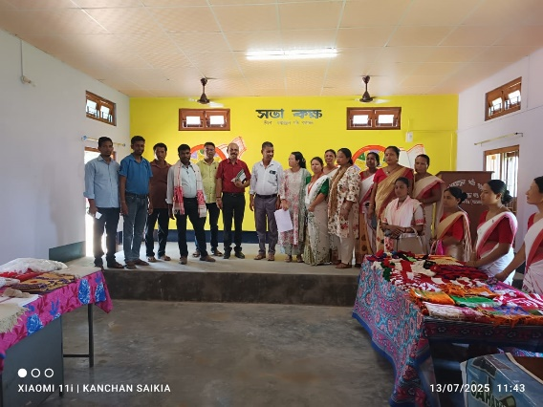

Skill Development & Capacity Building
We provide vocational training, employability skills, and capacity-building programmes for individuals and institutions. Our training interventions are designed to enhance skills, confidence, and long-term self-reliance.
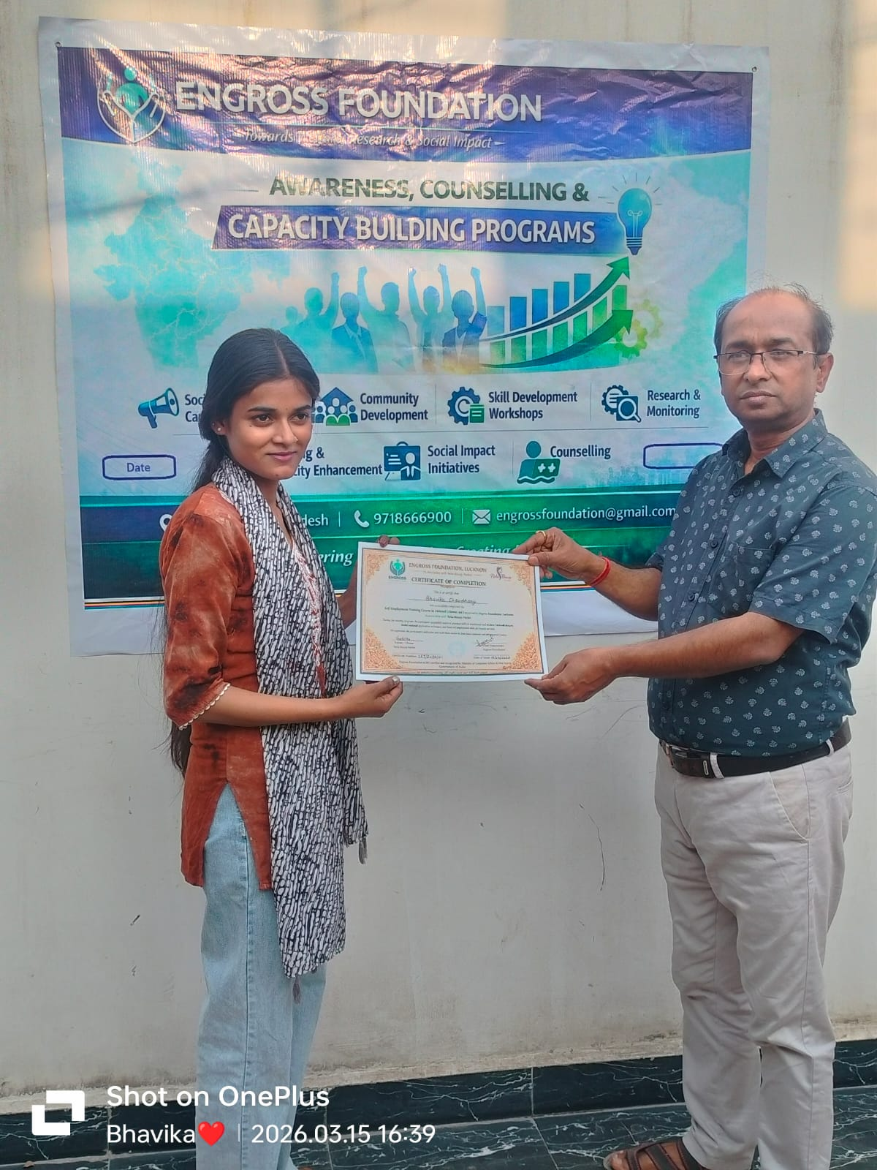

Health, Hygiene & Mental Well-being
We work to improve community health through awareness campaigns, preventive healthcare initiatives, and hygiene promotion. We also provide mental health and psychosocial support, especially during crisis situations.
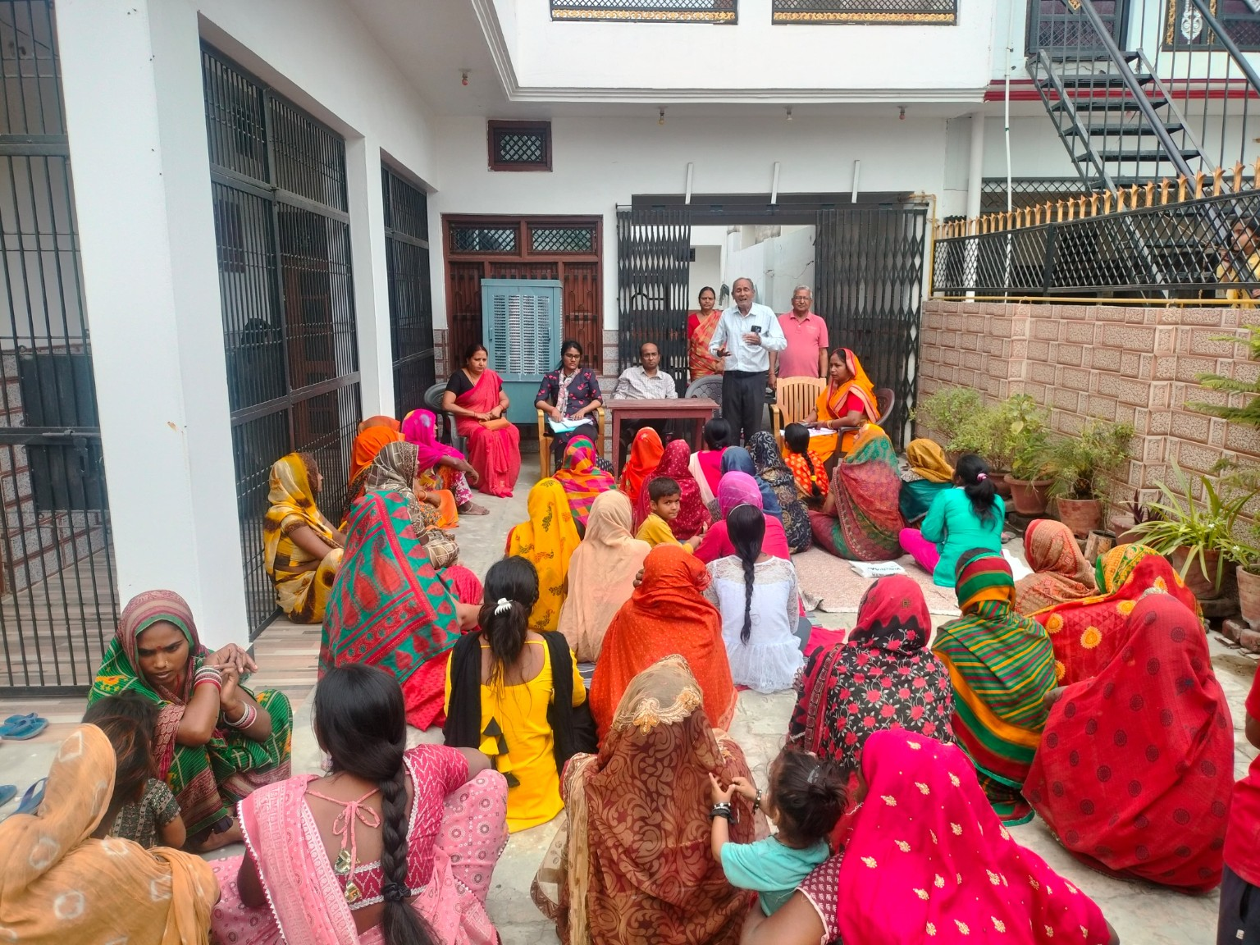

Disaster Management & Rehabilitation
Our disaster response initiatives include preparedness, emergency relief, psychological support, and post-disaster rehabilitation. We focus on building resilient communities capable of responding to and recovering from crises.
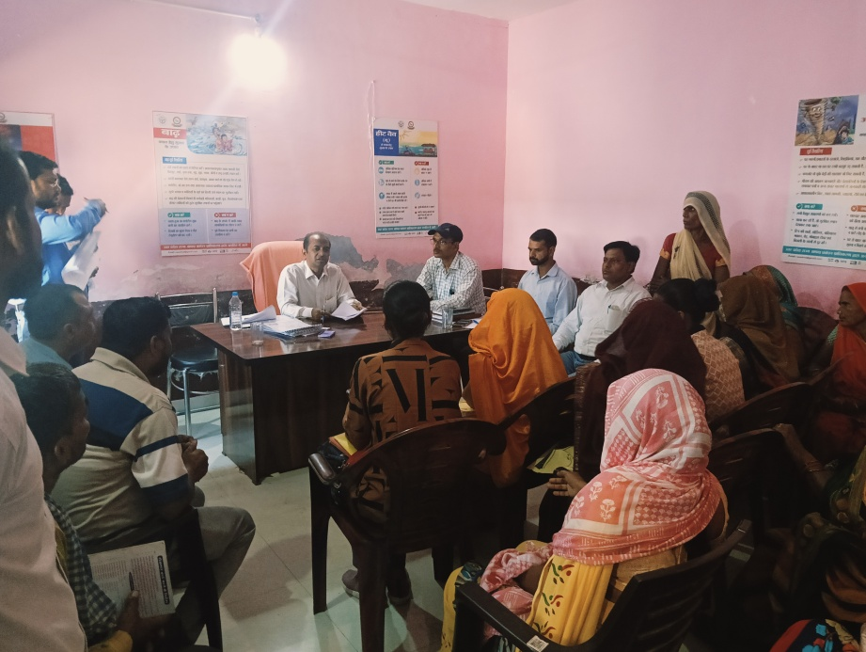

6. Social Welfare & Community Development
We implement welfare programmes aimed at empowering marginalized groups, including women, children, and youth. Our efforts focus on social inclusion, equity, and community participation.
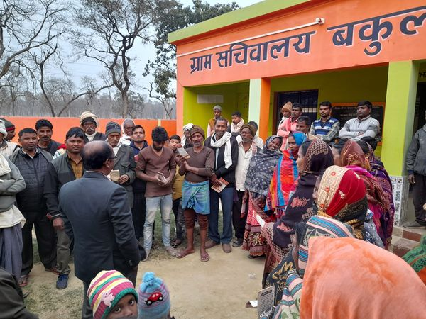

Awareness, Advocacy & Public Engagement
We conduct awareness campaigns and outreach programmes to promote government schemes, rights, and entitlements. Our advocacy efforts aim to bridge information gaps and enhance access to public services.

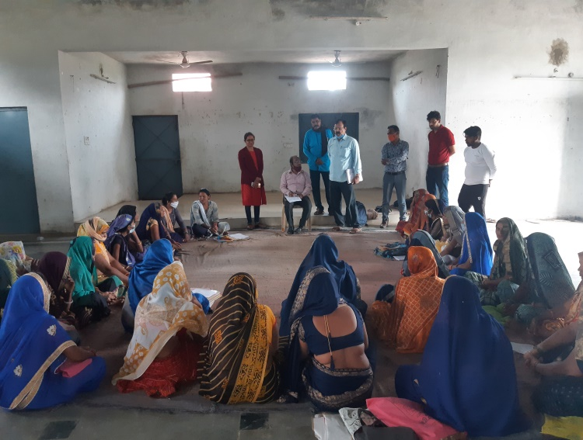

Environmental Sustainability & Organic Practices
We promote eco-friendly practices, organic farming, and sustainable resource management. Our initiatives encourage environmental conservation and climate-conscious community development.
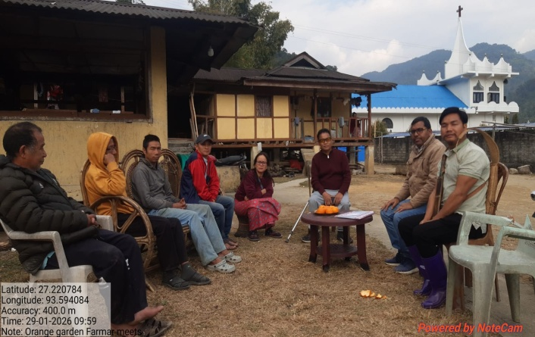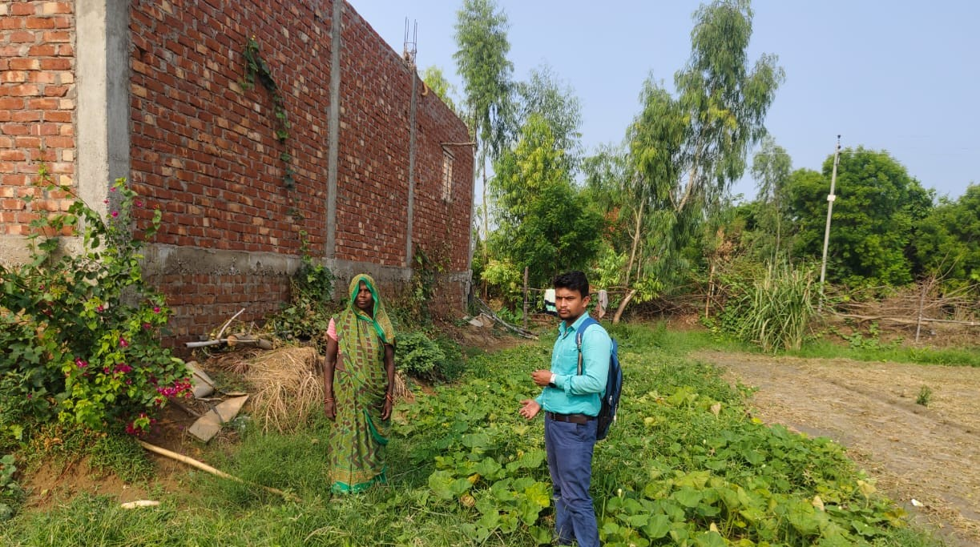

Monitoring, Evaluation & Policy Support
We provide monitoring and evaluation services, policy research, and technical consultancy to improve the effectiveness and impact of development programmes and public policies.
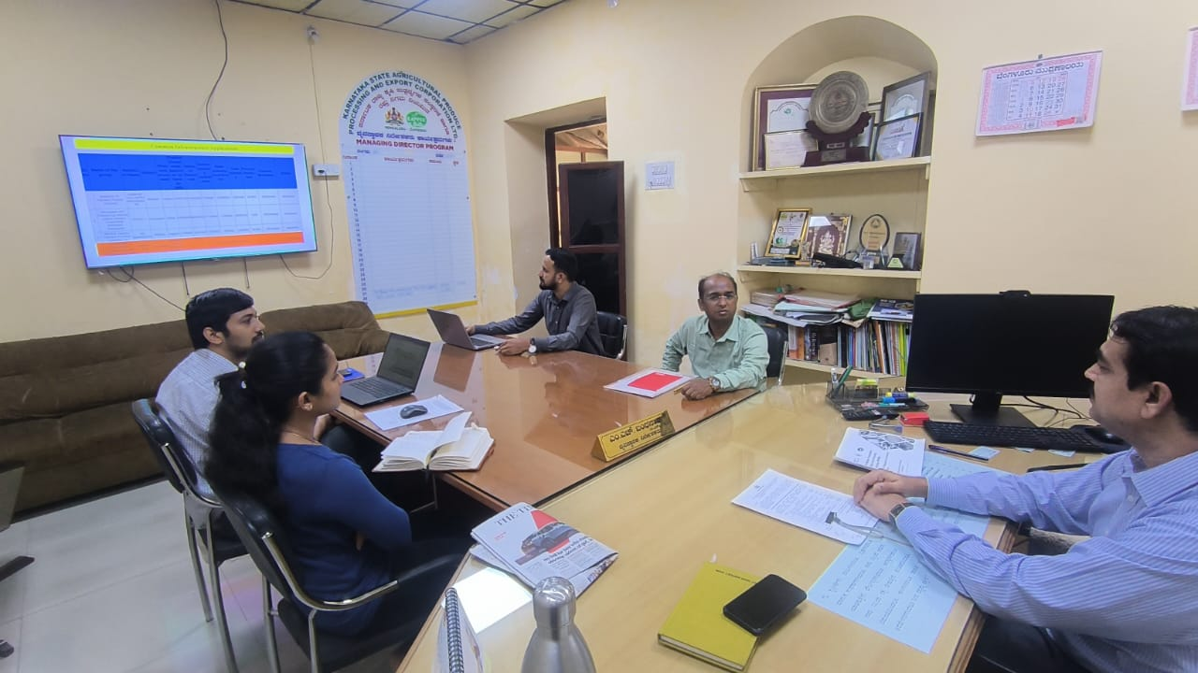

Our Approach
- Research and Evidence-Based Planning
- Community Participation and Inclusion
- Sustainability and Long-Term Impact
- Collaboration with Stakeholders and Institutions

